
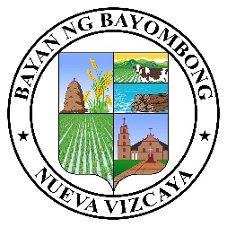


Republic of the Philippines
Province of Nueva Vizcaya
Municipality of Bayombong
ooOoo
BARANGAY LA TORRE NORTH
Provincial Road, La Torre North, Bayombong, Nueva Vizcaya Email: barangaylatorrenorthnuevvizcay@gmail.com Philippines, 3700 TEL#s - (078) 321-4745 / 392-1894 Contact Numbers: 0916-174-9428/0927-570-6819
FB Page: Barangay La TORRE NORTH
SANGGUNIANG BARANGAY

JOEL C. CASTRICIONES
Punong Barangay

BARANGAY KAGAWADS

MILAGROS P. PADILLA

VILLAFUERTE T. MARTINEZ JR.

MELITA P. SANCHEZ

IRENE C. BAJO

VIRGIL P. COVITA

CAROLINA V. VICENTE

JOSEPH P. ESTEBAN

SAMUEL JAMES B. DEL ROSARIO
SK Chairperson
BARANGAY CLEARANCE

TO WHOM IT MAY CONCERN:
This is to CERTIFY that {name}, of legal age, {civilStatus}, is a bona fide resident of {purok}, Barangay La Torre North, Bayombong, Nueva Vizcaya. {HE_SHE} is known in this locality to be a peaceful and law-abiding citizen of good moral character and reputation.
Records of this barangay show that there are no derogatory remarks against {HIM_HER}. {HE_SHE} has never been charged, indicted with, or convicted of any crime whatsoever, much less of having violated any of the existing ordinances of this barangay.
This CLEARANCE is being issued upon the request of the person mentioned above for {purpose}.
ISSUED this {day}^{{suffix}} day of {month}, {year}, at La Torre North, Bayombong, Nueva Vizcaya.
Certified By:
HON. {captainName}
Punong Barangay

NOTE: NOT VALID WITHOUT OFFICIAL SEAL
***** This is for a 1(one) single transaction only.

